Bryton Davis

Ms. Hull

English 2010

1 July 2011

The Legalization of Marijuana’s Effect on Crime,
Positive or Negative?

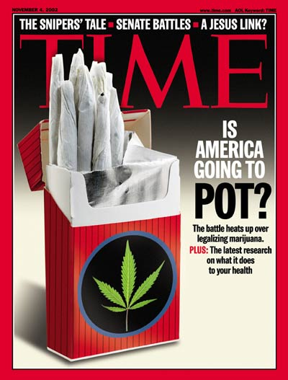
Figure 1: The Legalization of Marijuana is a debate nationwide.

Introduction
The legalization of marijuana, known as cannabis or pot, is a heated debate today and will continue to be debated and speculated until further research has silenced the issue. Whether or not the legalization of marijuana would be a beneficial or harmful legislation came up to a vote in California. Proposition 19, which would legalize the recreational use of marijuana, was turned down by a vote of 53.5% against and 46.5% for its legalization (Ballotpedia). Obviously, the vote came to a very narrow margin and supporters of legalization are hoping the vote will come up again in 2012. One of the main issues surrounding this debate was how would marijuana’s legalization affect crime rates? Supporters believe its legalization will allow law enforcement officers freedom to enforce other laws, while opponents believe marijuana is a gateway drug and will lead to more problems and crime related with other, more powerful drugs, and that it will lead to more accidents involving marijuana use.

Police Officers Can Focus on Other Crimes?
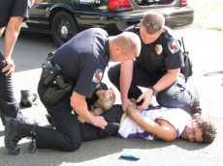
Many of the supporters of marijuana’s legalization believe that if marijuana was legalized, crime rates would decrease and law enforcement officers could focus on other, more violent crimes. “It will also free that state’s police officers to concentrate on crimes that inflict the deepest fear, pain and loss: burglaries, robberies, sexual assaults, domestic violence, stalking, child abuse, workplace and school shootings, drunk driving” (Stamper). Norm Stamper, a former Seattle Police Chief, is not alone in this belief. Many people believe that the enforcement of marijuana-related laws is taking up entirely too much time for law enforcement officers. According to the FBI, in 2009 a total of 858,408 people were arrested for marijuana-related crimes. 99,815 of those arrests were for drug trafficking and distribution of marijuana (Drug War Facts). Many believe that this number would drastically decrease, allowing police officers to focus on other, more serious crimes. In Kentucky, a Drug Enforcement Agency led by Lieutenant Roper spends 8 hours a day hunting for marijuana, costing tax payers 1.4 million dollars yearly (Marijuana USA). Many believe this is a waste of time and money and could and should be put to what they think would be more productive use in catching other criminals doing other, more serious crimes.
Figure 2: Police Officer arresting someone on marijuana related charges. Supporters believe police officers will be able to focus on other, more violent crimes.
However, there are also many who believe that marijuana’s legalization would not only fail to allow police to focus on other crimes, it would make things worse.
This proposition would burden [law enforcement] with new and complicated enforcement duties. The proposition would require officers to enforce laws against ‘ingesting or smoking marijuana while minors are present.’ Would this apply in a private home? And is a minor ‘present’ if he or she is 15 feet away, or 20? Perhaps California law enforcement officers will be required to carry tape measures next to their handcuffs. (Kerlikowske, Walters, McCaffrey, Brown, Martinez, and Bennett)
Granted, law enforcement won’t need to carry tape measures but the point is valid to many. The Proposition is vague and where to draw the line is up for interpretation. Where would minors be considered “present?” Where would the line be drawn? Lieutenant Roper, the Kentucky DEA, is 100% against marijuana’s legalization. He believes that its legalization would just cause more and more problems. He believes it is a losing situation for the state and for the nation and vowed that Kentucky would be the last state to ever allow marijuana to be legalized (Marijuana USA).
Marijuana Is a Gateway Drug?
Another fear of the opponents of Proposition 19 is that marijuana is a gateway drug and would just lead to more problems involved with other, more dangerous drugs such as methamphetamine, cocaine, heroin, etc. One of their arguments is that marijuana use is addictive and once its effect wears off after continued use, the only other viable solution to users would be other, stronger, more dangerous drugs. According to the National Institute on Drug Abuse, marijuana can be up to 5 times as potent as the cannabis of the 1970’s (Kershaw, Cathcart). Many believe that this increased potency is making addiction more and more common, and making marijuana use increasingly related to other drug use.
However, supporters of the Proposition claim marijuana is not addictive and definitely not a gateway drug. They believe that this argument is just a common misconception used to scare people out of legalizing marijuana. One such supporter of legalization is Time Magazine’s Szalavitz, who believes that marijuana and other drug use is just a correlation.
[A] person who smokes marijuana is more than 104 times more likely to use cocaine than a person who never tries pot, according to the National Institute on Drug Abuse.
The problem here is that correlation isn't cause. Hell's Angels motorcycle gang members are probably more 104 times more likely to have ridden a bicycle as a kid than those who don't become Hell's Angels, but that doesn't mean that riding a two-wheeler is a "gateway" to joining a motorcycle gang. It simply means that most people ride bikes and the kind of people who don't are highly unlikely to ever ride a motorcycle. (Szalavitz)
Correlation is not causation. This is a well-known fact among the scientific community. To supporters of legalization, and Szalavitz, marijuana’s role as a gateway drug is just a correlation, not fact.
Different studies have proven different results, but whether there are medical reasons tying marijuana use as a gateway drug is still unknown and up for debate. If there is a direct link, crime rates will most likely not drop seeing as once marijuana users want to try a new drug to get a new high, they will again have to go through illegal drug trafficking corporations to get it, increasing the crime rates supporters believed would decrease.

Driving Under the Influence of Marijuana
Another argument that opponents of marijuana’s legalization use is that more and more accidents would occur because of marijuana use. Drunk driving is a huge problem in the United States and they believe that if marijuana is legalized, driving under the influence of cannabis will just add on to this problem. Some opponents of legalization believe that THC, the main ingredient in marijuana that gives users their high, effects driving performance just like alcohol does.
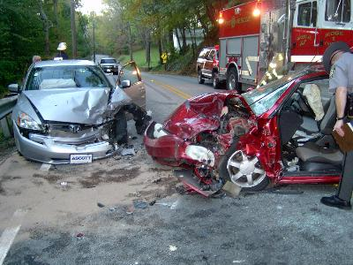
In a scientific study involving multiple test subjects performed by the University of Maastricht these results were found: “The results of the studies corroborate those of previous driving simulator and closed-course tests by indicating that THC in inhaled doses up to 300 µg/kg has significant, yet not dramatic, dose-related impairing effects on driving performance” (Robbe). THC and alcohol were compared in this study, and it was found that while THC isn’t quite as impairing as alcohol, it does impair the performance of the driver.
Figure 3: Car crash involving the driver being under the influence of marijuana.
However, supporters believe that this just simply isn’t true. They believe that studies such as this one performed by Robbe were either incorrectly performed or had too few test subjects to observe effects. In other studies, very few effects were observed, supporters counter.
Much to everyone's surprise, the results of these studies revealed only relatively small impairments in driving skills, even after quite large doses of the drug. Several of the early studies showed no impairments at all, but as the driving simulators grew more sophisticated and the tasks required more complex and demanding, impairments were observed, for example, in peripheral vision and lane control. Marijuana users, however, seem to be aware that their driving skills may be impaired and they tend to compensate by driving more slowly, keeping some distance away from the vehicle ahead and in general taking less risks. (Iverson 91)

Conclusion
The debate over the legalization of cannabis is very heated and likely to come up to a vote again in 2012. Whether or not its legalization would be beneficial to society or not is up to your own interpretation. The effect on crime rates is speculative and very opinionated, from both sides. It will be interesting to see what happens with this debate in the future when more research over the drug and its effects have been tested.

Works Cited
Ballotpedia. "California Proposition 19, the Marijuana Legalization Initiative (2010)." Wikimedia. Web. 22 June 2010.
Common Sense for Drug Policy. "Marijuana | Drug War Facts." Welcome | Drug War Facts. Web. 22 June 2011.
Iversen, Leslie L. The Science of Marijuana. Oxford: Oxford UP, 2000. Print.
Kerlikowske, Walters, McCaffrey, Brown, Martinez, Bennett. “California should just say no; Legalizing marijuana through Prop. 19 would only add to the state’s problems.” Los Angeles Times. 25 August 2010. Web. 22 June 2011.
Kershaw, Sarah, and Rebecca Cathcart. "Marijuana Is Gateway Drug for Two Debates." New York Times, 17 July 2009. Web. 22 June 2011.
Marijuana USA. Prod. Mitch Weitzner. CNBC. 2010. Documentary.
Robbe, HWJ. "Marijuana's Effects on Actual Driving Performance." Institute of Human Psychopharmacology, University of Maastricht. Web. 23 June 2011.
Stamper, Norm. "Legalization Will Reduce Crime Rates, Free Up Police Resources." CNBC. 20 Apr. 2010. Web. 22 June 2011.
Szalavitz, Maia. "Marijuana as a Gateway Drug: The Myth That Will Not Die – TIME Healthland." TIME Magazine. 29 Oct. 2010. Web. 22 June 2011.
Images:
Figure 1: TIME. “Is America Going To Pot.” TIME Magazine. 4 November 2002. Print.
Figure 2: Johnson, Julie R. Corning Observer. 12 Oct. 2010. Web. 22 June 2011.
Figure 3: Reasons to Oppose Medical Marijuana in Arizona. 22 August 2010. Web. 22 June 2011.

