Bryton Davis

Physics 1010

Ms. Noon

28 July 2011

X-rays

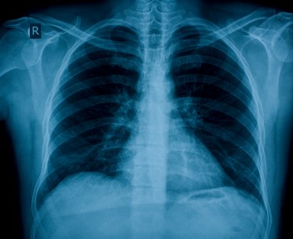
Figure 1: X-ray showing the chest cavity.

Introduction
X-rays are a huge part of our life today. If you have ever broken a bone, or have had other health issues, you have probably dealt with X-rays at least once in your life. Their application in the medical world and even in the real world is stunning. Without them, diagnosis of broken bones, swallowed objects, etc, would be much harder. Checking baggage would also be much harder; instead of just photographing it, we would have to check it be hand. X-rays are very useful. Now you might be thinking, who invented the x-ray and how did he invent it? How does the x-ray work? And how does it help in the medical world and in the real world? We’ll go into these questions throughout the rest of this paper.

Invention
On November 8th, 1895, Wilhelm Conrad Röntgen accidentally discovered the X-ray when his cathode ray generator projected an image far beyond the possible range of cathode rays. Upon further investigation, Wilhelm found that the rays were not deflected by magnetic fields, and that they penetrated many kinds of matter. After this discovery, he took an X-ray photograph of his wife’s hand which revealed her wedding ring and her bones. This discovery shocked the world and led to other studies and investigations among the scientific world (Bellis).
Cold cathode tubes, the tube Wilhelm used in his experiment, were used for years to photograph x-rays. This all changed when William Coolidge invented the Coolidge x-ray tube in 1913. This was a lot more reliable than the cold cathode tubes and was overall just better. However, like most superior inventions, the Coolidge tube didn’t replace cold cathode tubes immediately. In fact, cold cathode tubes were used in radiology up until the 1960’s (Frame).
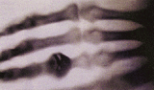
X-rays have continually been updated and improved upon since the late 19th and early 20th century. We also now know of the dangers associated with x-rays. Sadly, Röntgen and his wife did not know of the dangers of x-radiation and his wife died of the effects of x-radiation. Unfortunately, after hundreds of experiments of unprotected exposure to x-radiation, it will kill you, like it did to Röntgen’s wife.
Figure 2: The first X-ray ever. Mrs. Röntgen's hand, which clearly shows her bones and wedding ring.

How It Works
X-rays are a form of electromagnetic radiation with a frequency higher than that of ultraviolet waves but lower than that of gamma rays. X-rays work by heating a cathode to a high temperature, which causes electrons to break away from the cathode. Because the electrons are now freely floating, they become attracted to the anode at the opposite side of the vacuum tube and move over to the anode at a great velocity. Once the electron hits the anode an x-ray photon is forced to be released. In a small opening in the vacuum tube, the rays escape in a concentrated beam, which travels until it comes into contact with our skin (The Radiology Blog).
Soft tissue inside of our body cannot absorb the ray because the ray is of such a high energy. Therefore, the high energy ray passes straight through the soft tissue. However, the highly dense material which is our bones, and other materials that we happen to swallow or guns we happen to be carrying into an airport, absorb the radiation. The rays that don’t contact the highly dense material of bones or other objects pass through to a film detector, which works like plain camera film. The highly dense material that absorbed the radiation appears white on the x-ray photograph. The radiation that passed through the body and soft tissue and came into contact with the film detector appears black on the photograph (The Radiology Blog).

Real World Uses
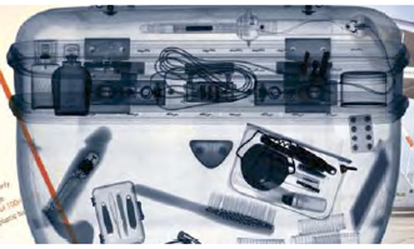
The applications of X-rays are astounding. X-rays are an extremely useful tool in the medical world. They can see straight past tissue and examine broken bones, check for cavities, and analyze swallowed objects inside the body. However, x-rays aren’t exclusively used in the medical world. Many different businesses use x-rays as a tool for many different uses.
Figure 3: An x-ray picture of the contents inside luggage. Airports use x-rays in their security system to make sure harm to others is not incurred to others.
X-rays have been pivotal in research involving quantum mechanics theory, crystallography and cosmology. In the industrial world, X-ray scanners are often used to detect minute flaws in heavy metal equipment. And X-ray scanners have become standard equipment in airport security, of course. (Harris)
X-rays are extremely important in the security world. Police stations, airports and almost every government building use x-radiation to make sure people walking into the building with luggage aren’t carrying firearms or explosives that could lead to personal injury to others. However, every once in a while something goes wrong and people get injured or killed.

Conclusion
X-radiation is a very useful and interesting tool in our world today. Without it, our world would be a very different place. Imagine you fell off of your ladder and landed on your hand funny. Or while moving a stove up the stairs, the dolly you were using to help move the stove slipped and the stove chased you down the stairs and landed on your ankle (which happened to my mom). Without x-rays, your doctor could very well have to diagnose your injured hand or ankle solely by touching the area of discomfort. This would kind of suck. X-rays are awesome and very nice to have.

Works Cited
Bellis, Mary. "History of the X-Ray." Inventors. About.com. Web. 28 July 2011.
Frame, Paul. "Coolidge X-ray Tubes - General Information." Oak Ridge Associated Universities (ORAU) - Oak Ridge, TN. 24 June 2009. Web. 28 July 2011.
Harris, Tom. “HowStuffWorks How X-rays Work." HowStuffWorks "Science." Web. 28 July 2011.
The Radiology Blog. "How Do X-Rays Work?" The Radiology Blog. 4 Jan. 2009. Web. 28 July 2011.

Images
Figure 1: Dr. Chris. "Chest Pain Test - Heart and Lung X-Ray, ECG Stress Tests | Healthhype.com." Current Health Articles. HealthHype.com. Web. 28 July 2011.
Figure 2: Bellis, Mary. "History of the X-Ray." Inventors. About.com. Web. 28 July 2011.
Figure 3: "How to Get Even With Someone!" Aviation Humor. 8 Dec. 2010. Web. 28 July 2011.

